**User Guide for Project “ Event Calendar”**

1. The following screen appears when the application is run.

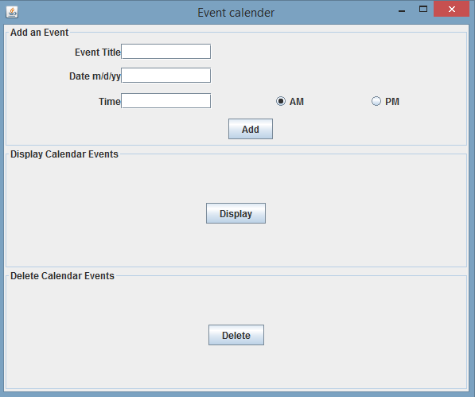

1. Add event details and click the “Add” button

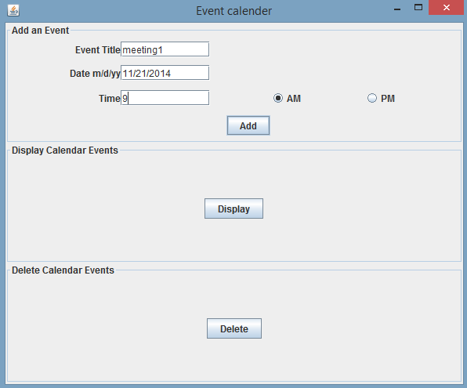

1. To add another event , delete the earlier entries as they are not auto-clearing after clicking on “Add”.

Add more such events and then click “Display” to display all events. Following is a snapshot of the same.

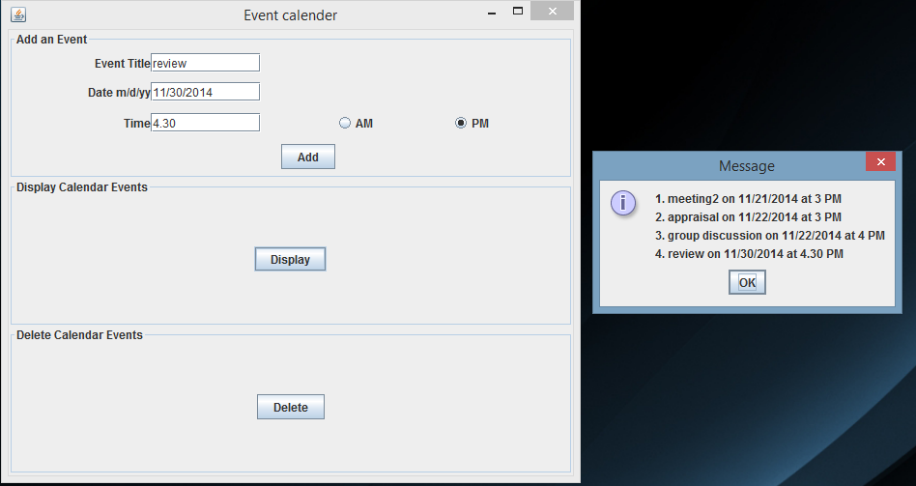

1. To delete an event, click the “Delete” button. Enter the number displayed beside the event.

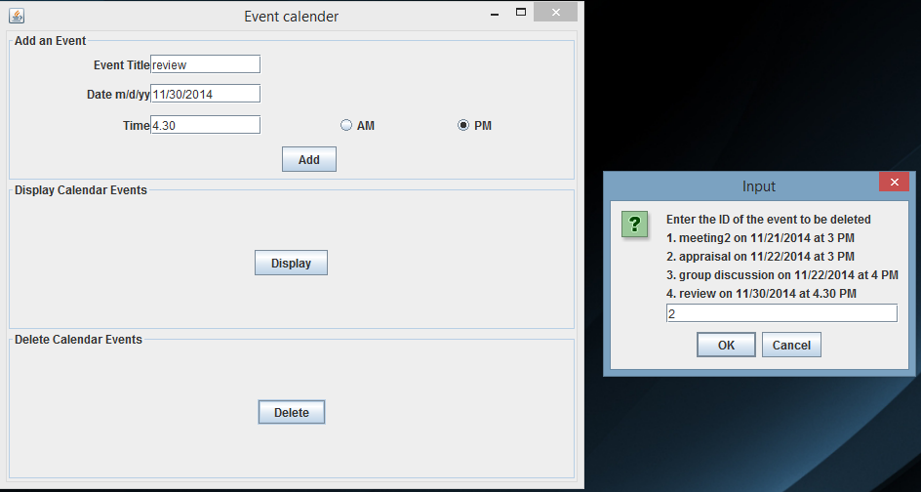

1. To check if the event is deleted, click “Display” and view the fresh list of events.

